Chapter 7: Snow Avalanches (avalanches for short)

Snow avalanches – masses of snow, generally a few cubic metres in volume, that separate from the intact snowpack and slide or flow downslope

* May travel as a coherent block or it may rapidly disintegrate into small particles that move independently of one another
* Most occur in remote, uninhabited mountains during fall, winter and spring

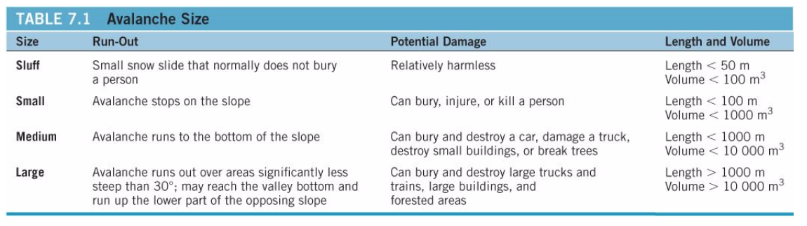

Snow Climatology

* Length of the snow season depends mainly on latitude and altitude
* Amount of snow on the ground depends on slop of the land, elevation, amount of snowfall and winds
  + Snow accumulates on slopes less than about 45o

Types of Avalanches

1. Point release avalanches
   * Begin with failure of a small amount of loose fluffy snow
   * Widens as it moves downslope
   * Commonly happen after a heavy snowfall
2. Slab avalanche
   * Snowpack fractures along a weak layer at depth
   * Gravity causes the snowpack to creep downslope with the top of the snowpack moving faster than the bottom
   * Moves a cohesive block
   * More dangerous than point release avalanches

Snowpack structure (Weak layers)

* New snow that has not had time to bond to the layer below is susceptible to sliding
* Compacted snow is less likely to move than light powdery snow
* Weak layers required for slab avalanches can form by
  + Wind
    - Blowing snow can build up on sheltered lee slopes and wind can stabilize the snowpack on other slopes
    - Wind slab – a body of thick, poorly bonded snow deposited by wind
    - Leeward slope, where the snow accumulates, is said to be top-loaded
    - Wind blowing parallel to a ridge crest can also deposit snow, producing cross loaded
  + Formation of hoar at depth in the snowpack
    - Hoar consists of ice crystals that are deposited on snow and within the snowpack when the air is moist and cold
    - Layers of hoar generally have lower strength than the rest of the snowpack
    - Forms from air occupying space between snow crystals
  + Formation of hoar at the surface
    - Surface hoar/hoar frost consists of ice crystals that form at the surface of the snowpack on cold clear nights
    - Change slowly once buried
    - Overlying and underlying snow layers gain strength, leaving the buried surface hoar as a weak layer

Avalanche motion

* During the first few seconds of a slab avalanche, the failed snow mass is a coherent slab compromising fractured blocks of snow
* With a few tens of metres, the slab disintegrates into smaller fragments
* Dry avalanches generate a cloud of powdered snow that billows above the flowing mass
  + Have recorded at 200km/h which can give them sufficient momentum to climb opposing slopes
* Wet avalanches contain liquid water and do not achieve the high velocities of dry avalanches

Avalanche Triggering

* Most avalanches occur naturally during or soon after snowstorms
* Normal daytime heating or an inflow of warm air raises the temperature of the snowpack
* In recreational accidents, avalanche typically triggered by a person
* Some avalanched are triggered intentionally as part of avalanche control programs

Avalanche Paths

1. Start zone – where the snowpack fails
2. Track – path of acceleration and maximum velocity
3. Run out zone – deceleration and deposition

Terrain Factors

* Slope angle
  + Most important terrain factor for avalanche formation
  + Avalanches tend to occur on slopes with angles between 25 and 60 degrees
  + Most large avalanches occur between 30 and 45 degrees
  + Sluffs happen on steeper slopes of more than 60o
* Orientation of slope
  + Leeward slopes are more likely to have avalanches – they accumulate large amounts of snow in wind slabs and cornices
  + Sun facing slopes are more prone to avalanches during sunny, warm weather
  + Shaded slopes are more prone to avalanches in cold weather
* Other
  + Convex slopes are more dangerous than concave
  + Avalanches are more common on smooth slopes
  + Vegetation may anchor the snowpack
  + Gullies or ravines can funnel avalanches, increasing their destructive force

Avalanches can occur almost anywhere with snow and a sufficiently steep slope for snow to slide on

Impacts of Avalanches

* Human deaths – 600 in Canada since mid 1800s
* Economic losses – destruction and blockage of roads, property damage
* Damage to forests; soil removal

Links to other natural hazards

* Earthquakes can trigger avalanches
* Climate change may increase snowfall

Natural Service Functions

* Increase local plant and animal diversity
* Provides open areas for wildlife

Increased Human Interaction with Avalanches

* Building developments are encroaching into areas prone to avalanches
* Winter leisure and recreation activities have increased in popularity

Minimize risk

* Location of infrastructure – risk is estimated by determining avalanche frequency, distribution and size
* Structures – fences, nets, berms, avalanche sheds, mounds are used for protection
* Triggering – explosive charges are projected from cannon, fired by artillery or dropped from helicopters
* Forecasting based on:
  + Observed occurrences of avalanches
  + Stability and strength tests: shovel, compression and rutshblock tests
  + Snowpack observations
  + Weather

Avalanche Rescue

* Avalanche cords
* Avalanche transceivers
* Probes
* Shovels
* Avalanche dogs

Avalanche survival – depends on the length of the time the person is buried and the burial depth

* 92% survive is rescued within 15min
* 30% survive after 35 min
* almost 0% after 2 h
* only 5-10% survive if burial is more than 1.5m deep